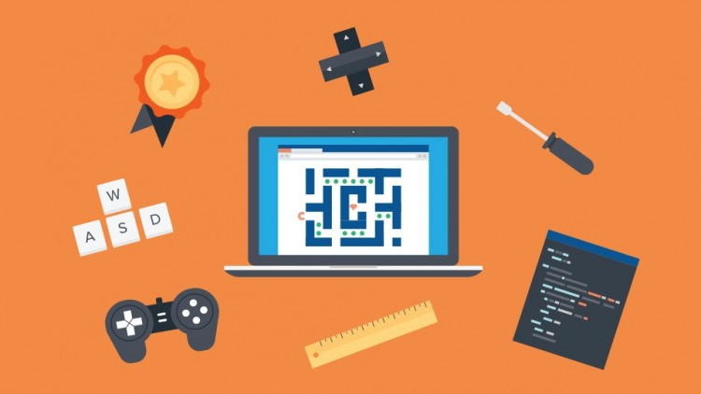

Project Design Document

Mobile Application Design 2

Darragh Lally | g00220290 | 2020

Contents

Introduction 2

Research 2

- Formats - 2

i. Classic 3

ii. Top-Down 3

iii. Vertical & Horizontal 3

- Shooter - 4

- Psychology of gaming – 4

i. Competency 4

ii. Autonomy 4

iii. Relatedness 4

Design 5

- Storyboard – 5

i. Splash Screen / Load Screen 5

ii. Main Menu 6

iii. High Score 6

iv. Settings 6

v. Game Play 7

vi. Pickups 9

vii. Game Controls 10

viii. Music & Sound 10

Conclusion 11

Recommendations 12

References 13

# Introduction

Our task is to research, design and develop a 2D shooter game for our 6th semester module ‘Mobile Application Development 2’. We are to use Unity as our development platform and are required to complete the project with no additional packages/assets. This is our second time been exposed to Unity, although our first was minimal so there is a learning curve to overcome - but this gives us an opportunity to work on our C# skills. We will also get to increase our knowledge in our planning and preparation abilities, document writing and research methods and all the while building something fun that will hopefully be enjoyed by many people.

An idea immediately sprang to mind, but for the purpose of the project and to meet the projects requirements I shall first research other game types/styles and come to a final decision at the end of the time I have allocated to research.

There are many genre and styles available to work from. I began my research with a simple Google search….

# Research

The specifications of the project have helped eliminate a substantial amount of research. I know I am required to make a 2D shooter, example ‘Space Invaders’. There are many different styles and views to choose from. Below are some of the formats best suited to 2D games, as proven through success stories such as the example mentioned in this document.

## - Formats -

There are many formats to consider when designing a game. For this project we were recommended to investigate the following. All are conducive to a third person style of game.

### i. Classic

When I think of classic style 2D games Mario immediately pops into my mind. This game is iconic with its conception dating back to 1981. The user has a side view of the character and levels, the gameplay brings the player in a direction to the right of their screen. While this is not technically a shooter it is a great example of the classic style of 2D game.

### ii. Top-Down

Space Invaders, Grand Theft Auto (The original!), surviv.io the list goes on and on… These are all examples of top down shooters, wildly varying in styles.

Everyone who is anyone knows Space Invaders, I hope. First released in 1978 there has been a release for most gaming platforms from arcade to mobile and I would bet it will be available (in some format) for years to come and as technology moves on. The user’s view is looking directly down onto the characters and the level design.

### iii. Vertical & Horizontal

When one thinks of a vertical/horizontal game formats, there is a question that comes to my mind… Does it mean the direction of game play or the view of the screen?

1. **Direction of Play**: Considering the examples above, I would suggest Mario to be of horizontal format where-as Space Invaders is in a vertical format.
2. A close up of electronics

   Description automatically generated**View**: If the display is positioned for normal viewing, that is, like on a TV or monitor the view is said to be in a horizontal position, i.e. it is wider than it is tall. Think of a phones display orientated in a landscape direction. On the other hand, if the game image is said to be taller than it is wide then we would consider this to be in a vertical position, i.e. the phone image in portrait orientation.

## - Shooter -

I love shooters, they come in all shapes and sizes! Single player, multi-player online or LAN, click to shoot, continuous fire, duck, dodge, third person, first person, you think of it and there is probably one for you. For this project though we will start small!

Shooters are a sub-set of the more general genre of action/adventure games. There are literally thousands of available examples in all the formats you can think of. Simple examples like Space Invaders (third person) or more recent and complex implementations like Call of Duty (first person). The goal in a shooter is for the player, represented by an avatar, to be able to use, and possibly collect, weapons of a projectile nature to inflict damage on enemy avatars. The end game differs depending on the game type, example highest score over a certain timeline – *Call of Duty* -, Endless waves of enemies – *Space Invaders* -, level style – *Plants vs Zombies* - and many more.

## - Psychology of gaming –

Whether or not we believe it, psychology in gaming is a well-studied and published topic. One major contributor to the subject is Scott Rigby and his company ‘[Immersyve](http://immersyve.com/)’, who have published their study on what makes gaming so appealing. They discovered that gaming targets 3 specific psychological needs:

### i. Competency

Relates to the feeling of accomplishment. People generally like to feel as if they are good at something. We also like to have some form of recognition for our achievements. We get this in games as we progress through difficulties and learn the mechanics that give our avatar the optimum advantages.

* I will try to recreate this psychological aspect by, making my game progressively more difficult by increasing the scene speed after a predefined distance/checkpoint and/or increasing the health of the enemies.

### ii. Autonomy

Relates to our desire for independence we want to feel in control of our actions. Take the game Red Dead Redemption 2 which offers autonomy as the player can choose their own path to the end game.

* I will try to recreate this psychological aspect by, giving the user the choice to play for distance, kills or both during that specific play session.

### iii. Relatedness

Is the feeling that we matter to others, that we can make a difference within a group. MMO’s are the best example of this, take ‘World of Warcraft’ for example. The online community is massive, giving an individual the chance to connect and develop relationships with other, usually similarly minded, individuals.

* I will try to recreate this psychological aspect by, having a ‘Top Score Board’ counting the top ‘n’ players [name, kill amount, distance]. This way players can try and better their peer’s achievements.

# Design

For my project I am going to try and implement an ‘Endless-Runner’ style shooter. My idea is for one continuous level that progressively gets more difficult as the player gains distance. To implement this difficulty, I will increase the run speed, the enemy frequency and the health stats of the enemies. A player will have two end game stats to beat, hopefully enticing them to come back for more –

1. Number of Enemies Killed, this will be the primary scoring system. For example, I will give one point for each regular enemy kill and 2 points for a boss. The scores will stay consistent throughout the users ‘run’, i.e. a regular enemy will always be worth one point.
2. The distance ran by the user. This will be a secondary scoring system but gives the option for the user to decide between two game styles – 1. Shooter and 2. Endless Runner

I decided on this scoring method because of the game I want to build. The player will have the choice of either shooting to kill the enemy in front of them or to dodge by jumping over or crouching under. This will become clearer in the Storyboard. The player losses their life by running into an enemy. This is a one life per run game, which leaves me the option of adding a player-pickup like an extra life.

## - Storyboard –

### i. Splash Screen / Load Screen

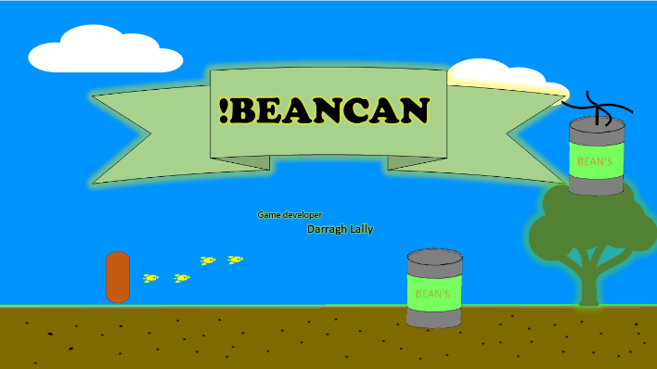I want to add a splash screen, not because the game will take significant time to load… it shouldn’t! But because I want to display the name of the game and developer. I feel that is a nice introduction to a game. I plan on displaying it for approx. 3 seconds. Be aware, Unity by default adds their own splash screen when using the community version of their software.

### ii. Main Menu

My menu will be the first interactable screen/scene in my game, my plan is to also implement a suitable version of the menu for the in game ‘Pause Menu’. I want to give the following options to the user –

1. **Play:** Starts a new game
2. **High Scores:** A table displaying the top n players names and scores – both kills and distance
3. **Options:** Here the player will be able to turn on and off Sound and Music for the game. This will either be a main menu option or a ‘Gear Button’ at the bottom of the menu screen. I can also add options for future additions to the game here, like changing the control layout from right to left-handed.
4. **Exit:** I hate games that have a convoluted way of exiting, it really grinds my gears – So I am adding a simple escape for my users. It will be of the same size and style of the user’s other options therefor leaving no ambiguity!A screenshot of a cell phone

   Description automatically generated

### iii. High Score

This main menu option will display a top score board with both number of enemies killed, and the distance ran on that particular ‘Run’. I will initially display the top 5 or 10 but could enhance in the future with a live board.

### iv. Settings

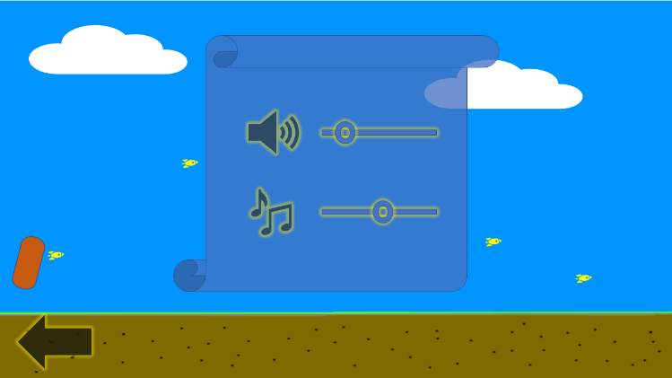This will be both a main menu option and an in-game pause option. I will initially allow the user to control the sound effects and music volume output. This will also allow the user to mute the game.

### v. Game Play

The game is going to be one continuous level that progressively gets more difficult, via several methods, listed below. The player avatar will have the illusion that they are moving in a right-handed direction. Enemies will spawn off screen and to the right on two different levels. The user’s goal is to eliminate as many bean cans as they can and/or run as far as possible. If they hit a bean can they are added to it and therefor the game ends. This is inevitably going to be the end game in all circumstances other than the user quitting the game or their device losing power.

Methods of increasing the difficulty:

1. The game pace will increase after distance intervals, for example after every 20 meters I will increase the speed at which the player needs to react to on coming enemies.
2. By increasing the enemy’s health, for example the first 10 enemies may be killed with one hit, increasing to two hits for the next 10 and following that pattern.
3. Increasing the enemy spawn frequency.

I will have to think of a way to restrict these difficulty increases within certain parameters, that is the distance the player has ran is in some way comparable to the kill difficulty of the enemies and the frequency in which enemies spawn.

#### Scene 1

The user will be met with a similar screen upon entering the game mode via a button press on the main menu scene ‘Play’

I want to add a pop up explaining to the player how to shoot, I want to bind the ‘Shift Key’ to shoot. This is so I can in the future add an option for changing from right-handed to left-handed controls.

#### Scene 2

This scene is to demonstrate projectiles been fired from the player avatar towards the enemy.

#### Scene 3

Here we see the players projectiles destroy the enemy bean can!

#### Scene 4

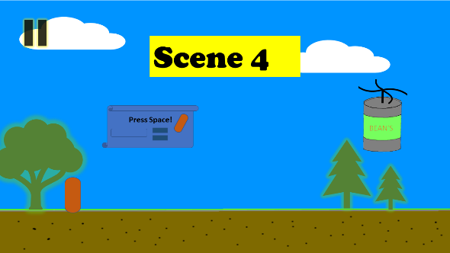In this scene the player is introduced to a new enemy type, this enemy spawns in on a different level and brings a new challenge to the player. I prompt the player with controls for their jump movement. I will map the space bar to the jump action. A jump and shoot movement will kill this enemy.

#### Scene 5

Here we see the player avatar in the jump motion while projectiles make their way to the enemy.

#### Additional Movement

In this image I am displaying the jump and crouch movements which, apart from shoot, are the users only control’s over their avatar. It gives the player the following options.

1. Jump over a ground enemy
2. Jump to get a shot on a flying enemy
3. Crouch under a flying enemy

#### Dash

In my ‘Dash’ I am going to have a pause button, settings button and both the kill count and the distance in meters ran.

This is going to be the style of my game and how I envisage the scenes within it. A continuous run in one direction with the player either dodging or destroying enemy objects. The pace will increase after certain distances. I will randomly generate scenery outside the view to make it look as though the player is running past a changing environment. I intend on having two spawn points for enemies, which will randomly spit out an enemy object.

### vi. Pickups

I want pickups available to the player to give them an advantage as the game gets more difficult. These pickups will have a time limit on their active status.

#### Multi-shot

This pick up will mean the player can burst shoot with each key press rather than the default one shot per press.

#### Shield

This pick up will give the player a shield which makes them invincible for a short time period.

#### Slow-Down

This pickup will slow down the pace of movement for a time period, making it easier for the player to dodge or kill the enemy objects.

#### Ammo

All good shooters let the player run out! Meaning we need a pickup to replenish those valuable rounds!

### vii. Game Controls

Because my game is an endless runner, I don’t need to give the user the usual W, A, S, D and Spacebar controls. My user’s avatar will have the illusion of continuous movement to the right of the screen. I want my player to be only able to jump, crouch and shoot.

#### Shoot

I will map the ‘*Shift Key*’ for the player to shoot, this leaves me the option of giving control layout options to the user, i.e. left or right-handed.

#### Jump

I will map the ‘*Spacebar*’ for the player to jump. Double tap for a double jump.

#### Crouch

I will map the ‘*ctrl key*’ for the player to crouch. Giving them the opportunity to duck under an enemy can.

### viii. Music & Sound

I want a relaxing loop been played through out the players run. I have found it difficult to find license free clips online so will probably end up using sound/music assets from Unity (<https://assetstore.unity.com/lists/free-music-28797>). These are some of the other options I looked at:

1. [Audioblocks](https://www.audioblocks.com/collections/video-game-music) requires a paid account to download files.
2. [dl-sounds](https://www.dl-sounds.com/royalty-free/category/game-film/video-game/) has a very limited selection.
3. I thought I was on the right road when I came across this [answer](https://answers.unity.com/questions/7743/where-can-i-find-music-or-sound-effects-for-my-gam.html), but alas any of the sites mentioned are no good to me.
4. [This](https://www.newgrounds.com/audio/) is the only place I found that has a decent selection and free licenses.

I plan on adding SFX to specific actions/events within the game. This will hopefully enhance the players emersion in the game. Listed below are some events that I want to give SFX to, using examples of Onomatopoeia to describe the sound;

**Action SFX**

Running Rustle

Jumping Boing

Crouching Zip/Swoosh

Shooting Ping

Enemy Hit Ting

If I find the time and the free software, I might try to design some of the SFX and add to the project later.

# Conclusion

As stated in the introduction I will be using Unity’s Development Platform to build my game. As we cover new material in the lab, I intend on adding it to my project, slowly building the game over the next few weeks until I am happy with the final product. I do anticipate not having the time to implement all my ideas, but it leaves me the opportunity to expand on the game in the future. My aim is to implement the core features of the game and add the extras with any spare time I have at the end of the semester before the project submission date.

I am happy with my game choice for several reasons:

1. We are been thought with a ‘Space Invaders’ style example, my game won’t be a direct copy.
2. As a personal choice I enjoy side view games over top-down.
3. I am giving the end user two choices when it comes to game play
4. A shooter, as requested in the project brief.
5. An endless runner, with no need to shoot enemies!

While my scene and character mockups are some-what crude, I believe I get the idea of my game across and hope to be able to enhance the visual experience throughout the development process. Although I intend on keeping the cartoon style, as I feel it fits well with the 2D style of development. I will also add animation to the player’s avatar and to the enemies.

My target audience is open to all ages, male or female but is for a causal gamer. The type of game you play waiting for the bus or in the loo!

# Recommendations

* To be completed at the end of the build phase of the project.

# References

Game Design Documents:

<https://stemchallenge.org/resources/game-design-documents/>

<https://www.reddit.com/r/gamedesign/comments/7ze7xq/finished_game_design_document_examples/>

Mario image:

<https://www.google.com/url?sa=i&source=images&cd=&cad=rja&uact=8&ved=2ahUKEwjp5OHYjqbnAhXBh1wKHcZMB8sQjhx6BAgBEAI&url=https%3A%2F%2Fwww.gamespot.com%2Fforums%2Fsystem-wars-314159282%2F2d-mario-games-or-2d-sonic-games-31606576%2F%3Fpage%3D1&psig=AOvVaw2bIRram5wfLo7mCi4pwjYQ&ust=1580294701811438>

Space Invaders image:

<https://www.google.com/url?sa=i&source=images&cd=&cad=rja&uact=8&ved=2ahUKEwjMlOivj6bnAhVOZcAKHbZ7CKcQjhx6BAgBEAI&url=https%3A%2F%2Fwww.classic-retro-games.com%2Fgames%2Fshooters%2Fspace-invaders--59&psig=AOvVaw05eopflLsBNXuFeFhmQ629&ust=1580294750930844>

Vertical & Horizontal:

<https://www.aceamusements.us/vertical-versus-horizontal-video-games-arcade-cabinets-monitors-and-multicades.html>

Phone Orientation:

<https://www.google.com/url?sa=i&source=images&cd=&cad=rja&uact=8&ved=2ahUKEwiFspHLjKbnAhVwQUEAHd2xDA0Qjhx6BAgBEAI&url=https%3A%2F%2Fsupport.docusign.com%2Fen%2Farticles%2FWhy-does-my-phone-ask-me-to-Rotate-Phone-or-Rotate-to-Draw-when-signing&psig=AOvVaw2Wk6CSQgw4Fo76NlZZqysM&ust=1580294144075570>

Shooters:

<https://en.wikipedia.org/wiki/Shooter_game>

Psychology of gaming:

<https://www.sekg.net/gamer-psychology-people-play-games/>

<https://www.psychreg.org/why-people-play-video-games/>

<https://www.teachthought.com/learning/why-people-play-video-games/>

<https://www.sciencedirect.com/science/article/pii/S0268401216307897>

Music and Sound:

<https://www.audioblocks.com/collections/video-game-music>

<https://www.dl-sounds.com/royalty-free/category/game-film/video-game/>

<https://answers.unity.com/questions/7743/where-can-i-find-music-or-sound-effects-for-my-gam.html>

<https://www.newgrounds.com/audio/>

<https://www.noisehelp.com/examples-of-onomatopoeia.html>